**CIS 480 Project – Injection 1**

**Injection**

* Happy Monday Morning! The early bird gets the worm and it doesn't get much earlier than this huh? I'm your incredibly overbearing CIO and I feel the need to check up on my rockstar security team at all hours of the day and night!
* Please respond to this injection with the following information.
  + Identify the leader
  + Introduce the team and describe the roles and responsibilities of each member during the exercise. (Do not take this seriously and just describe what each is going to do. One paragraph is enough.)
* Provide your response to this injection at the end of this document.
* Each team needs to make one submission for each injection. The team leader shall make submission on behalf of the team.
* Follow the naming convention for the submission. Use this format: CIS480Prj-classX-injY-teamZ.docx, where X is 1 for sec01 and 2 for sec76, Y is injection number, and Z is your team number on the team roster.)
* Each injection is worth 10 points.
* I rearranged the team numbers. So, your need to make sure your team number.

1. Section 01:

<https://docs.google.com/spreadsheets/d/117sDg-HgpMAjco1Np9FT0AK2elFoxOCt-bUJ-9RjHFo/edit#gid=0>

1. Section 76:

<https://docs.google.com/spreadsheets/d/1OHi17OKT8ZpUsxf5tJ0QOwPh0I3giDGcqUQmj6_V58Y/edit#gid=0>

* The injections also are posted on the Teams channel. Use Teams **Posts** for inquiries. Contacting the professor and the admin (Levi Walton) via email is prohibited.

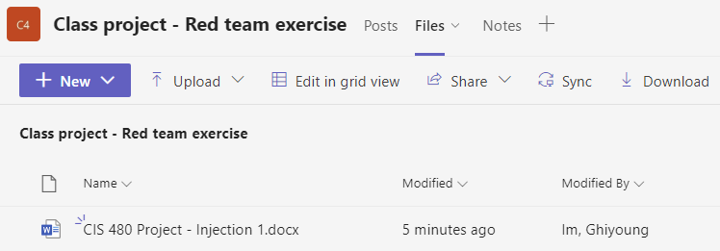

* Schedule

|  |  |  |  |
| --- | --- | --- | --- |
| **Weeks** | **Injections** | **Post** | **Due (midnight)** |
|  | Injection 1 – Introduce the team | Mon, 7th | Tue, 8th |
|  | Injection 2 – Scan the network | Tue, 8th | Wed, 9th |
|  | Injection 3 – Break into the target | Wed, 9th | Fri, 11th |
|  | Injection 4 – File transfer | Wed, 9th | Fri, 11th |
|  | Injection 5 – Treasure hunt | Thur, 10th | Sat, 12th |

**Response to Injection 1**

1. Team leader and members.

2. Roles and responsibilities, etc.